[PSoC 4 Pioneer Kit Community Project#17 - 2-Channel OScope with GraphicsLCD](http://www.element14.com/community/message/77536" \l "77536/l/psoc-4-pioneer-kit-community-project17--2-channel-oscope-with-graphicslcd)

 Today we're posting another Oscilloscope project that uses the [Color Graphics LCD Shield.](http://www.elecfreaks.com/store/color-lcd-shield-p-462.html) This project is a little dual channel scope using the PSoC 4 Pioneer board and the SparkFun Arduino color graphics shield or equivalent.

 The user input is via SW2 on the Pioneer board (none of the switches on the display are used). Tap the button to cycle through the options highlighted with a white box drawn around it. Hold the button for a second or more until the box moves to another parameter.

 *      Trigger Channel:  "TRG 1" or "TRG 2"

*      Trigger Level:    From 100mV to 5000mV

*      Input Range:      5000mV, 2500mV, 1250mV, 625mV, 312mV

*      Samples per Second:  SPS  10k, 20k, 50k, 100k, 200k, 400k

[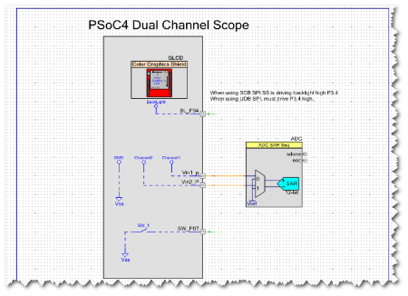](http://www.element14.com/community/servlet/JiveServlet/showImage/2-77536-149453/project17_schematic.png)

 Components used:

* Graphics LCD Component (over SPI)

* SAR ADC Component

* a few instances of the Pin Component

Software:

Inside the PSoC Creator project, you'll notice 2 Sources Files -

* main.c - this implements the main firmware for the project's user interface

* scope.c - this implements all of the oscilloscope functions

 Hardware Required:

* PSoC 4 Pioneer Kit

* Sparkfun or equivalent Nokia 6100 based Color Graphics LCD Arduino Shield

 Attachments:

PSoC Creator Project .zip file

<http://www.element14.com/community/message/77536>